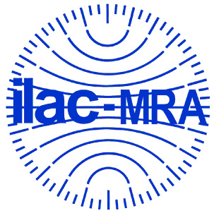
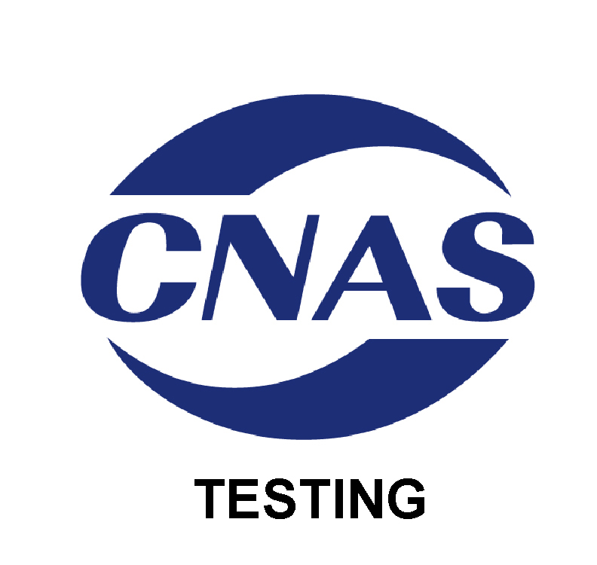

中国合格评定国家认可委员会
认 可 证 书 附 件
（注册号：CNAS L1659）
名称:中检集团南方电子产品测试（深圳）有限公司
地址：广东省深圳市南山区西丽街道西丽工业区石鼓东28、29栋
认可依据：ISO/IEC 17025、EPA能源之星以及CNAS特定认可要求
签发日期：2015年09月10日 有效期至：2018年09月28日
附件4 认可的“能源之星”检测能力范围
序号 | 检测  对象 | 项目/参数 |  | 检测标准（方法）名称及编号（含年号） | 限制  范围 | 说明
序号 | 检测  对象 | 序号 | 名称 | 检测标准（方法）名称及编号（含年号） | 限制  范围 | 说明
1 | 电视机（能源之星） | 1 | 全项目 | 能源之星电视机测试方法，能源之星对电视机的项目要求，版本7.0 2014
1 | 电视机（能源之星） | 2 | 功耗 | 音视频设备和相关设备的功耗测试方法IEC 62087:2008
1 | 电视机（能源之星） | 3 | 平均功耗 | 电视机平均功耗的检测 CEA-2037:2014
1 | 电视机（能源之星） | 4 | 待机功耗 | 家用电器的待机功耗测量 EN 50564:2011
1 | 电视机（能源之星） | 5 | DAM状态能耗 | CEA DAM测试流程：电视机 修订版 3.0 2010.9.8
2 | 音视频产品（能源之星） | 1 | 能效 | 能源之星音视频产品测试方法，能源之星对音视频产品的项目要求，版本3.0 2013.5
3 | 机顶盒（能源之星） | 1 | 能效 | 能源之星机顶盒产品测试方法，能源之星对机顶盒的项目要求，版本4.1 2014.12.
4 | 电话通讯设备（能源之星） | 1 | 能效 | 能源之星电话机产品测试方法，能源之星对电话机的项目要求 版本3.0 2014.10.
5 | 计算机（能源之星） | 1 | 全项目 | 能源之星计算机测试方法，能源之星项目要求，版本6.1 2014.9.
5 | 计算机（能源之星） | 2 | 能效 | EPRI 能源效率通用测试准则 AC-DC及DC-DC内置电源 6.4.3版 2009
5 | 计算机（能源之星） | 3 | 待机功耗 | 家用电器的待机功耗测量 EN 50564:2011
5 | 计算机（能源之星） | 4 | 能效 | 单路输出交流-直流和交流-交流外部电源能效测试方法 2004.8.11
6 | 计算机显示器（能源之星） | 1 | 全项目 | 能源之星显示器测试方法，能源之星项目要求，显示器产品规范，版本6.0 2013.6
6 | 计算机显示器（能源之星） | 2 | 图像设置 | VESA平板显示器测量标准，版本2.0
6 | 计算机显示器（能源之星） | 3 | 能效 | EPRI 能源效率通用测试准则 AC-DC及DC-DC内置电源 6.4.3版 2009
6 | 计算机显示器（能源之星） | 4 | 待机功耗 | 家用电器的待机功耗测量 EN 50564:2011
6 | 计算机显示器（能源之星） | 5 | 能效 | 单路输出交流-直流和交流-交流外部电源能效测试方法 2004.8.11
6 | 计算机显示器（能源之星） | 6 | 功耗 | 音视频设备和相关设备的功耗测试方法IEC 62087 :2008
7 | 成像设备（能源之星） | 1 | 全项目 | 能源之星成像设备测试方法, 能源之星项目要求，版本2.0 2014.1
7 | 成像设备（能源之星） | 2 | 能效 | EPRI 能源效率通用测试准则 AC-DC及DC-DC内置电源 6.4.3版 2009
7 | 成像设备（能源之星） | 3 | 能效 | 单路输出交流-直流和交流-交流外部电源能效测试方法 2004-8-11
7 | 成像设备（能源之星） | 4 | 待机功耗 | 家用电器的待机功耗测量EN 50564:2011
8 | 计算机服务器（能源之星） | 1 | 全项目 | 能源之星计算机服务器项目要求 测试方法，版本2.0 2013.12.
8 | 计算机服务器（能源之星） | 2 | 能效 | EPRI 能源效率通用测试准则 AC-DC及DC-DC内置电源 6.4.3版 2009
8 | 计算机服务器（能源之星） | 3 | 能效 | 单路输出交流-直流和交流-交流外部电源能效测试方法 2004-8-11
8 | 计算机服务器（能源之星） | 4 | 待机功耗 | 家用电器的待机功耗测量  EN 50564:2011
9 | 灯具（能源之星） | 1 | 部分项目 | 能源之星对灯具的项目要求 合格评定标准，版本1.1 2011 | 只测：荧光灯及固态照明
9 | 灯具（能源之星） | 2 | 性能测试 | 自镇流紧凑型荧光灯的性能规格  ANSI C78.5-2003
9 | 灯具（能源之星） | 3 | 性能测试 | 日光灯镇流器测量ANSI C82.2-2002
9 | 灯具（能源之星） | 4 | 性能测试 | 光源显色性测量Pub.No. 13.3-1995
9 | 灯具（能源之星） | 5 | 性能测试 | 比色法  Pub.No.15.2004
9 | 灯具（能源之星） | 6 | 性能测试 | IESNA LM-9-09 荧光灯管的电性能及光性能测量
9 | 灯具（能源之星） | 7 | 性能测试 | LM-40-01荧光灯管寿命测试
9 | 灯具（能源之星） | 8 | 性能测试 | IES LM-65-01 自镇流荧光灯寿命测试
9 | 灯具（能源之星） | 9 | 性能测试 | IESNA LM-66-00 单端自镇流荧光灯电性能及光性能测量
9 | 灯具（能源之星） | 10 | 性能测试 | LM-10-11 室外荧光灯光性能测量
9 | 灯具（能源之星） | 11 | 性能测试 | LM-41-11 室内荧光灯光性能测量
9 | 灯具（能源之星） | 12 | 性能测试 | LM-79-08 固态照明产品的电性能及光性能测量方法
9 | 灯具（能源之星） | 13 | 性能测试 | LM-58-11 分布光度计测量方法
9 | 灯具（能源之星） | 14 | 性能测试 | 谐波限值-灯具的功率质量要求  ANSI C82.77-2002
9 | 灯具（能源之星） | 15 | 性能测试 | LM-82-11 LED灯具电源及整体式LED灯的电性能及光性能
10 | 紧凑型荧光灯（能源之星） | 1 | 全项目 | 能源之星对紧凑型荧光灯的项目要求，版本4.3 2010
10 | 紧凑型荧光灯（能源之星） | 2 | 快速循环测试 | IES LM-65-01自镇流荧光灯寿命测试
10 | 紧凑型荧光灯（能源之星） | 3 | 性能测试 | IESNA LM-66-00单端自镇流荧光灯电性能及光性能测量
10 | 紧凑型荧光灯（能源之星） | 4 | 性能测试 | ANSI C78.5-2003自镇流紧凑型荧光灯的性能规格
10 | 紧凑型荧光灯（能源之星） | 5 | 性能测试 | Pub.No. 13.3-1995 光源显色性测量
10 | 紧凑型荧光灯（能源之星） | 6 | 性能测试 | IESNA LM-9-09 荧光灯管的电性能及光性能测量
11 | 不间断电源设备（UPS）（能源之星） | 1 | 全项目 | 能源之星对不间断电源的项目要求 版本1.0 2012
12 | 电源 | 1 | 平均效率能效限定值 | 能源之星单路输出交流-直流和交流-交流外部电源合格依据 (2.0版) 2010
12 | 电源 | 2 | 空载状态能效限定值 | 能源之星单路输出交流-直流和交流-交流外部电源合格依据 (2.0版) 2010

CHINA NATIONAL ACCREDITATION SERVICE FOR CONFORMITY ASSESSMENT
SCHEDULE OF ACCREDITATION CERTIFICATE
(Registration No. CNAS L1659)

NAME:CCIC Southern Electronic Product Testing(Shenzhen) Co., Ltd.
ADDRESS:Building 28/29, East of Shigu, Xili Industrial Zone, Xili Road, Nanshan District, Shenzhen, Guangdong, China
Accreditation Criteria:ISO/IEC 17025, requirements of EPA ENERGY STAR® Program and relevant requirements of CNAS
Date of Issue:2015-09-10 Date of Expiry:2018-09-28
SCHEDULE 4 ACCREDITED ENERGY STAR TESTING SCOPE
№ | Test Object | Item/Parameter |  | Title, Code of Standard or Method | Limitation | Note
№ | Test Object | № | Item/ Parameter | Title, Code of Standard or Method | Limitation | Note
1 | Television (Energy star) | 1 | All items | Energy Star Test Method for Televisions, Energy Star Program Requirements for Televisions, Version7.0
1 | Television (Energy star) | 2 | Signal setting | Methods of Measurement for the Power Consumption of Audio, Video and Related Equipment  IEC 62087, Ed.2.0
1 | Television (Energy star) | 3 | Average Power | CEA-2037: Determination of Television Average Power Consumption of Audio, Video and Related Equipment December 2009
1 | Television (Energy star) | 4 | Standby power | Household electrical appliances – measurement of standby power  EN 50564:2011
1 | Television (Energy star) | 5 | DAM stiutaiton | CEA: Procedure for DAM Testing Rev. 0.3 2010.9.8
2 | Audio /Video(Energy star) | 1 | Energy Efficiency | ENERGY STAR Program Requirements Product Specification for Audio/Video Version 3.0
3 | Set-top Boxes(Energy star) | 1 | Energy Efficiency | ENERGY STAR Program Requirements for Set-top Boxes Version4.1
4 | Telephony(Energy star) | 1 | Energy Efficiency | ENERGY STAR Program Requirements Product Specification for Telephony Version3.0
5 | Computer (Energy star) | 1 | All items | Energy Star Computer Test Method, Energy Star Program Requirements, Version 6.1
5 | Computer (Energy star) | 2 | Energy Efficiency | EPRI Generalized Test Protocol for Calculating the Energy Efficiency of Internal Ac-Dc and Dc-Dc Power Supplies, Rev. 6.4.3 2009
5 | Computer (Energy star) | 3 | Standby power | Household Electrical Appliances - Measurement of Standby Power  EN 50564:2011
5 | Computer (Energy star) | 4 | Energy Efficiency | Test Method for Calculating the Energy Efficiency of Single-Voltage External Ac-Dc and Ac-Ac Power Supplies, Aug. 11, 2004
6 | Computer Display (Energy Star) | 1 | All items | Energy Star Test Method for Displays, Energy Star Program Requirements Product Specification for Displays Rev 6.0
6 | Computer Display (Energy Star) | 2 | Signal setting | VESA FPDM Standard 2.0
6 | Computer Display (Energy Star) | 3 | Energy Efficiency | EPRI Generalized Test Protocol for Calculating the Energy Efficiency of Internal Ac-Dc and Dc-Dc Power Supplies, Rev. 6.4.3 2009
6 | Computer Display (Energy Star) | 4 | Standby power | Household Electrical Appliances - Measurement of Standby Power  EN 50564:2011
6 | Computer Display (Energy Star) | 5 | Energy Efficiency | Test Method for Calculating the Energy Efficiency of Single-Voltage External Ac-Dc and Ac-Ac Power Supplies, Aug. 11, 2004
6 | Computer Display (Energy Star) | 6 | Power Consumption | Methods of Measurement for the Power Consumption of Audio, Video and Related Equipment  IEC 62087, Ed 2.0
7 | Image equipment (energy Star) | 1 | All items | Energy Star Imaging Equipment Test Method, Energy Star Program Requirements Version 2.0, Product Specification for Imaging Equipment
7 | Image equipment (energy Star) | 2 | Energy Efficiency | EPRI Generalized Test Protocol for Calculating the Energy Efficiency of Internal Ac-Dc and Dc-Dc Power Supplies, Rev. 6.4.3 2009
7 | Image equipment (energy Star) | 3 | Energy Efficiency | Test Method for Calculating the Energy Efficiency of Single-Voltage External Ac-Dc and Ac-Ac Power Supplies, Aug. 11, 2004
7 | Image equipment (energy Star) | 4 | Standby power | Household electrical appliances – measurement of standby power  EN 50564:2011
8 | Computer Sever(Energy Star） | 1 | All items | Energy Star Program Requirements for Computer Servers Version 2.0
8 | Computer Sever(Energy Star） | 2 | Energy Efficiency | EPRI Generalized Test Protocol for Calculating the Energy Efficiency of Internal Ac-Dc and Dc-Dc Power Supplies, Rev. 6.4.3 2009
8 | Computer Sever(Energy Star） | 3 | Energy Efficiency | Test Method for Calculating the Energy Efficiency of Single-Voltage External Ac-Dc and Ac-Ac Power Supplies, Aug. 11, 2004
8 | Computer Sever(Energy Star） | 4 | Standby power | Household electrical appliances – measurement of standby power  EN 50564:2011
9 | luminaire(Energy Star） | 1 | Part of items | Energy Star Program Requirements Product Specification for Luminaires Version 1.1 2011 | Accredited only for Fluorescent lamps and SSL
9 | luminaire(Energy Star） | 2 | Performance testing | Specifications for Performance of Self-ballastedd Compact fluorescent  ANSI C78.5-2003
9 | luminaire(Energy Star） | 3 | Performannce testing | Method ofMeausrement of Fluorescent lampballast  ANSI C82.2-2002
9 | luminaire(Energy Star） | 4 | Performance testing | Method of Measuring and Specifying Color Rendering of Light Sources  Pub.No. 13.3-1995
9 | luminaire(Energy Star） | 5 | Performance Testing | Colorimetry  Pub.No.15.2004
9 | luminaire(Energy Star） | 6 | PerformanceTesting | IESNA LM-9-09 Electric and Photometric Measurements f Fluorescent Lamps
9 | luminaire(Energy Star） | 7 | Performance Testing | LM-40-01 Life Testing of Fluorescent lamp
9 | luminaire(Energy Star） | 8 | Performance Testing | IES LM-65-01 Life Testing of Compact Fluorescent Lamps
9 | luminaire(Energy Star） | 9 | Performace Testing | IESNA LM-66-00 Electrical and Photometric Measurements of Single-Ended Compact Fluorescent Lamps
9 | luminaire(Energy Star） | 10 | Performace Testing | LM-10-11 Photometric Testing of Outdoor Fluorescent Luminaires
9 | luminaire(Energy Star） | 11 | Performace Testing | LM-41-11 ApprovedMethod for Photometric Testing of Inddor Fluorescent Luminaires
9 | luminaire(Energy Star） | 12 | Performace Testing | LM-79-08 Electrical and Photometric Meaurements of Solid-State Lighting Products
9 | luminaire(Energy Star） | 13 | Performace Testing | LM-58-11 Guide to Spectroradiometric Measuremnts
9 | luminaire(Energy Star） | 14 | Performace Testing | Harmonic Emission Limits-Related Power Quality Requiremnts for Lighting Equipment  ANSI C82.77-2002
9 | luminaire(Energy Star） | 15 | Performace Testing | LM-82-11 Characterization of LED light engines and Integrated LED Lamps for Electrical and Photometric Properties as a function of temperature
10 | Compact Fluorescant Lamp (Energy Star) | 1 | All items | Energy Star Program Requiremnts for Compact Fluorescent Lamps(CFLs) Version4.3 2010
10 | Compact Fluorescant Lamp (Energy Star) | 2 | Rapid Cycle Stress Test | IES LM-65-01 Life Testing of Compact Fluorescent Lamps
10 | Compact Fluorescant Lamp (Energy Star) | 3 | Performace Testing | LM-66-00 Electrical and Photometric Measurements of Single-Ended Compact Fluorescent Lamps
10 | Compact Fluorescant Lamp (Energy Star) | 4 | Performace Testing | ANSI C78.5-2003Specifications for Performance of Self-ballastedd Compact fluorescent
10 | Compact Fluorescant Lamp (Energy Star) | 5 | Performace Testing | Pub.No. 13.3-1995 Method of Measuring and Specifying Color Rendering of Light Sources
10 | Compact Fluorescant Lamp (Energy Star) | 6 | Performace Testing | IESNA LM-9-09 Electric and Photometric Measurements f Fluorescent Lamps
11 | Uninterruptible Power Supplies（UPS）（Energy Star） | 1 | All items | Energy Star Program Requiremnts for Uninterruptible Power Supplies (UPSs) Version 1.0 2012
12 | power supply | 1 | The average efficiency of energy efficiency limit value | ENERGY STAR External Power Supply Sunset Proposal Memorandum 2.0  2010
12 | power supply | 2 | No-load state energy efficiency limit value

