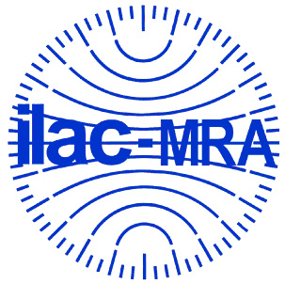
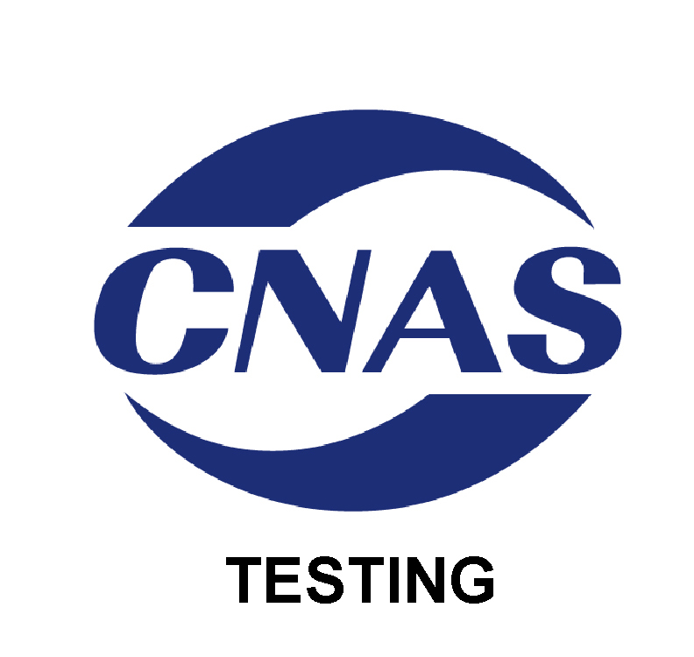

中国合格评定国家认可委员会
认 可 证 书 附 件
（注册号：CNAS L5998）
名称: 东莞市联鼎电子科技有限公司
地址：广东省东莞市南城区袁屋边车站北路恒正大厦1楼
认可依据：ISO/IEC 17025、EPA能源之星以及CNAS特定认可要求
签发日期：2016年01月05日 有效期至：2019年01月04日
附件4 认可的“能源之星”检测能力范围
序号 | 检测  对象 | 项目/参数 |  | 检测标准（方法）名称及编号（含年号） | 限制  范围 | 说明
序号 | 检测  对象 | 序号 | 名称 | 检测标准（方法）名称及编号（含年号） | 限制  范围 | 说明
1 | 音视频产品（能源之星） | 1 | 自动关机要求 | 能源之星音视频产品测试方法，能源之星对音视频产品的项目要求，版本3.0 2014.12
1 | 音视频产品（能源之星） | 2 | 空闲模式要求 | 能源之星音视频产品测试方法，能源之星对音视频产品的项目要求，版本3.0 2014.12
1 | 音视频产品（能源之星） | 3 | 休眠模式要求 | 能源之星音视频产品测试方法，能源之星对音视频产品的项目要求，版本3.0 2014.12
1 | 音视频产品（能源之星） | 4 | 视频播放测试 | 能源之星音视频产品测试方法，能源之星对音视频产品的项目要求，版本3.0 2014.12
1 | 音视频产品（能源之星） | 5 | 音频播放测试 | 能源之星音视频产品测试方法，能源之星对音视频产品的项目要求，版本3.0 2014.12
1 | 音视频产品（能源之星） | 6 | 功放类效率要求 | 能源之星音视频产品测试方法，能源之星对音视频产品的项目要求，版本3.0 2014.12
2 | 外置电源适配器 | 1 | 带载状态下的效率 | 加拿大能效法规（外置电源）版本2010.06  加拿大公报 CSA-C381.1-08 单相外置式Ac-Dc 和 Ac-Ac 电源适配器能源之星测试方法 版本2011.10  美国环保署对单相外置式Ac-Dc 和 Ac-Ac 电源适配器能源之星计划要求 10 CFR 第430部分附录Z.  美国环保署对单相外置式Ac-Dc 和 Ac-Ac 电源适配器能源之星测试方法 版本2.1 2004.08
2 | 外置电源适配器 | 2 | 空载状态下的功耗
3 | 电池充电器 | 1 | 充电模式下  能效 | 充电器BCS能源之星要求（Version 1.1）  充电器BCS能源之星的测量方法（Rev.Aug-2010）  碱性或其他非酸性电解液二次电池-单个密封便携式的可充电电池-第1部分：镍镉电池 （IEC 61951-1、 Ed. 2.1. 2006）  碱性或其他非酸性电解液二次电池-单个密封便携式的可充电电池-第2部分：镍氢电池 （IEC 61951-2、 Ed. 2.0. 2003）  含碱性或其它非酸性电解质的单体蓄电池和蓄电池-便携式锂单体蓄电池和蓄电池组（IEC61960、 Ed. 1.0. December 2003）
3 | 电池充电器 | 2 | 维持模式下  能效
3 | 电池充电器 | 3 | 待机模式下  能效
3 | 电池充电器 | 4 | 电池容量测量

CHINA NATIONAL ACCREDITATION SERVICE FOR CONFORMITY ASSESSMENT
SCHEDULE OF ACCREDITATION CERTIFICATE
(Registration No. CNAS L5998)

NAME:Dongguan UTL Electronic Technology Co., Ltd.
ADDRESS:1/F., Hengzheng Building, Chezhan North Road, Yuanwubian, Nancheng District, Dongguan, Guangdong, China
Accreditation Criteria:ISO/IEC 17025, requirements of EPA ENERGY STAR® Program and relevant requirements of CNAS
Date of Issue:2016-01-05 Date of Expiry:2019-01-04
SCHEDULE 4 ACCREDITED ENERGY STAR TESTING SCOPE
№ | Test Object | Item/Parameter |  | Title, Code of Standard or Method | Limitation | Note
№ | Test Object | № | Item/ Parameter | Title, Code of Standard or Method | Limitation | Note
1 | Audio/Video (ENERGY STAR) | 1 | Auto Power Down (APD) Function | ENERGY STAR Test Method for Audio/Video, ENERGY STAR Program Requirements Product Specification for Audio/Video Version 3.0, Effective Dec-2014
1 | Audio/Video (ENERGY STAR) | 2 | Idle State
1 | Audio/Video (ENERGY STAR) | 3 | Sleep Mode
1 | Audio/Video (ENERGY STAR) | 4 | Video Playback Test | ENERGY STAR Test Method for Audio/Video, ENERGY STAR Program Requirements Product Specification for Audio/Video Version 3.0, Effective Dec-2014
1 | Audio/Video (ENERGY STAR) | 5 | Audio Playback Test
1 | Audio/Video (ENERGY STAR) | 6 | TEST PROCEDURES FOR PRODUCTS WITH AUDIO AMPLIFICATION
2 | Single-voltage external ac-dc and ac-ac power supplies | 1 | Energy-Efficiency Criteria for Active Mode | Canada’s Energy Efficiency Regulations (External Power Supplies) June 2010; including amendment as published in the Canada Gazette, October 2011  - CSA-C381.1-08: Test method for calculating the energy efficiency of single-voltage external ac-dc and ac-ac power supplies  U.S. EPA ENERGY STAR Program Requirements for Single Voltage External AC-DC and AC-AC Power Supplies  - Appendix Z to 10 CFR part 430.  US EPA “Test Method for Calculating the Energy Efficiency of Single-Voltage External AC-DC and AC-AC Power Supplies”dated August 11, 2004.
2 | Single-voltage external ac-dc and ac-ac power supplies | 2 | Energy Consumption Criteria for No-Load | Canada’s Energy Efficiency Regulations (External Power Supplies) June 2010; including amendment as published in the Canada Gazette, October 2011  - CSA-C381.1-08: Test method for calculating the energy efficiency of single-voltage external ac-dc and ac-ac power supplies  U.S. EPA ENERGY STAR Program Requirements for Single Voltage External AC-DC and AC-AC Power Supplies  - Appendix Z to 10 CFR part 430.  US EPA “Test Method for Calculating the Energy Efficiency of Single-Voltage External AC-DC and AC-AC Power Supplies”dated August 11, 2004.
3 | Battery Charging Systems | 1 | Measuring Nonactive Energy -Charging Mode | ENERGY STAR Program Requirements Product Specification for Battery Charging Systems - Eligibility Criteria (Version 1.1),  ENERGY STAR Test Method for Battery Charging Systems, Rev. Aug-2010,  IEC Standard  61951-1: Secondary cells and batteries containing alkaline or other non-acid electrolytes – Portable sealed rechargeable single cells – Part 1: Nickel-cadmium. Ed. 2.1. January 2006,  IEC Standard  61951-2: Secondary cells and batteries containing alkaline or other non-acid electrolytes – Portable sealed rechargeable single cells – Part 2: Nickel-metal hydride. Ed. 2.0. April 2003,  IEC Standard  61960: Secondary cells and batteries containing alkaline or other non-acid electrolytes – Secondary lithium cells and batteries for portable applications. Ed. 1.0.  December 2003.
3 | Battery Charging Systems | 2 | Measuring Nonactive Energy -Maintenance Mode | ENERGY STAR Program Requirements Product Specification for Battery Charging Systems - Eligibility Criteria (Version 1.1),  ENERGY STAR Test Method for Battery Charging Systems, Rev. Aug-2010,  IEC Standard  61951-1: Secondary cells and batteries containing alkaline or other non-acid electrolytes – Portable sealed rechargeable single cells – Part 1: Nickel-cadmium. Ed. 2.1. January 2006,  IEC Standard  61951-2: Secondary cells and batteries containing alkaline or other non-acid electrolytes – Portable sealed rechargeable single cells – Part 2: Nickel-metal hydride. Ed. 2.0. April 2003,  IEC Standard  61960: Secondary cells and batteries containing alkaline or other non-acid electrolytes – Secondary lithium cells and batteries for portable applications. Ed. 1.0.  December 2003.
3 | Battery Charging Systems | 3 | Measuring Nonactive Energy -Standby Mode | ENERGY STAR Program Requirements Product Specification for Battery Charging Systems - Eligibility Criteria (Version 1.1),  ENERGY STAR Test Method for Battery Charging Systems, Rev. Aug-2010,  IEC Standard  61951-1: Secondary cells and batteries containing alkaline or other non-acid electrolytes – Portable sealed rechargeable single cells – Part 1: Nickel-cadmium. Ed. 2.1. January 2006,  IEC Standard  61951-2: Secondary cells and batteries containing alkaline or other non-acid electrolytes – Portable sealed rechargeable single cells – Part 2: Nickel-metal hydride. Ed. 2.0. April 2003,  IEC Standard  61960: Secondary cells and batteries containing alkaline or other non-acid electrolytes – Secondary lithium cells and batteries for portable applications. Ed. 1.0.  December 2003.
3 | Battery Charging Systems | 4 | Battery Ernergy Measurement | ENERGY STAR Program Requirements Product Specification for Battery Charging Systems - Eligibility Criteria (Version 1.1),  ENERGY STAR Test Method for Battery Charging Systems, Rev. Aug-2010,  IEC Standard  61951-1: Secondary cells and batteries containing alkaline or other non-acid electrolytes – Portable sealed rechargeable single cells – Part 1: Nickel-cadmium. Ed. 2.1. January 2006,  IEC Standard  61951-2: Secondary cells and batteries containing alkaline or other non-acid electrolytes – Portable sealed rechargeable single cells – Part 2: Nickel-metal hydride. Ed. 2.0. April 2003,  IEC Standard  61960: Secondary cells and batteries containing alkaline or other non-acid electrolytes – Secondary lithium cells and batteries for portable applications. Ed. 1.0.  December 2003.

